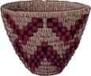
Confederated Tribes of the Chehalis Reservation

Request for Proposal

MBR Building Structural Repairs & Improvements – Roof
RFP# 202608-1A1
Amended Schedule
Submission Due Date: October 23, 2026

1.1 Project Description
The Confederated Tribes of the Chehalis Reservation Planning Department seeks proposals from qualified firms and individuals for the purpose of repairing or improving the MBR Plant Building and specifically the roof and ventilation systems to address structural and safety shortcomings as identified in the Scope of Work.
This project is located at the MBR Plant (18999 MBR Ln, Rochester, WA 98579), east and south of the Lucky Eagle Casino.
All contractors will be required to possess a Tribal Business License. Licenses can be obtained from the Planning department at an annual cost of $50 for non-Native companies and $20 for Native. Any required permits are the responsibility of the awarded contractor(s).

1.2 Proposal Submission Instructions
A Notice of Intent to submit a proposal must be received no later than Friday, September 25, 2026, 2:00pm Pacific time.
The Proposal must be received by Friday, October 23, 2026, 2:00pm Pacific time, in order to be considered. Proposals may be mailed, hand-delivered, or emailed to the following addresses:

Mailing Address: The Chehalis Tribe Planning Department
Attention: Chris Moffet
420 Howanut Road
Oakville, WA 98568

Physical Address: The Chehalis Tribe Planning Department
Attention: Chris Moffet
6 Niederman Road
Oakville, WA 98568

Email Address: cmoffet@chehalistribe.org

All proposals submitted on time will be reviewed and evaluated privately by a team within the Planning Department. Proposals will be evaluated on the evaluation criteria described in this RFP.

1.3 Communications
The Tribe’s representative for receiving questions, requests for clarification, or other communications about this RFP is Chris Moffet, Utilities Construction Project Manager, 360-709-1826 (office), 360-791-9912 (cell), or cmoffet@chehalistribe.org.

All requests for clarification of the RFP must be made in writing (email is acceptable) addressed to this representative and must be submitted no later than Friday, October 16, 2026. All answers to questions will be made in writing and delivered via email to all potential bidders who request such notification and provide an email address.

A fee for the production and mailing of physical printed documents requested from your organization may be charged.

1.4 Pre-Bid Meeting
A Pre-Bid meeting will be held at the MBR Plant (18999 MBR Ln, Rochester, WA 98579) on Wednesday, September 29, 2026, at 10:00am to answer questions about the project. Meet at the southeast corner of the Lucky Eagle Casino Parking Lot. For information regarding the proposed work, contact Chris Moffet, 360-789-1826, cmoffet@chehalistribe.org

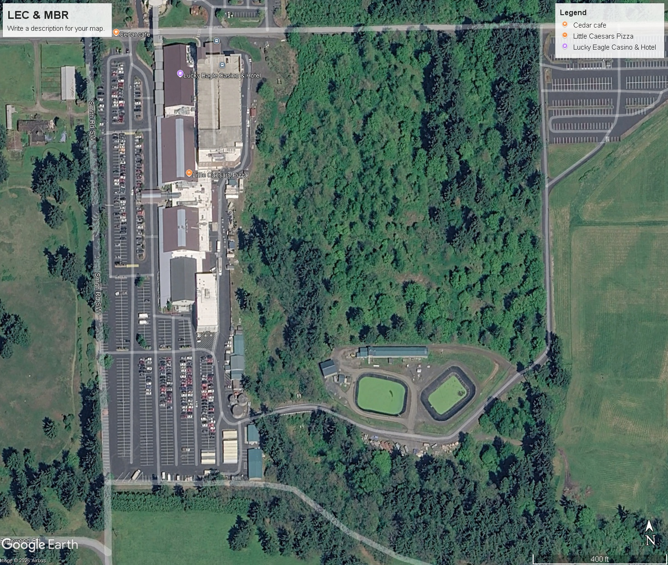
MBR

1.5 Award of Contract
Proposals will be opened on Monday, October 26, 2026, and scored according to the evaluation criteria described herein. The proposal with the highest adjusted score will be awarded the contract. A contract will be presented and signed. This shall serve as the Notice to Proceed. All contractors that submit a proposal will be notified no later than Wednesday, October 28, 2026 on the outcome of the selection process. If no proposal is deemed sufficient or receives an acceptable score, all proposals will be rejected.
The Chehalis Tribe reserves the right to waive irregularities and to reject any and all proposals.

2. Scope of Work
The MBR building has issues that have come about due to weather and natural damage, adverse environmental conditions, wear and tear, and normal usage. A detailed list focused on the roof follows this description. It is the Tribe’s desire that repairs or replacement/ improvements be completed is such a manner that mitigates the issues, extends the life of the building and its contents, and improves the desired functions of the building components.

Bid Item Number | Item | Issue | Desired End Result
1 | Roof (Steel panels) – Gable 1st level, west end of building. | Loosened, corroded, punctured, and leaky panels | Repair or replace, use metal panels resistant to environmental factors. Match roof pattern and color as close as possible.
2 | Roof (Steel Panels) – Gable 2nd level, Beginning approximately 25’ east of Monitor Roof to the east end of roof. | Loosened, corroded, and punctured panels | Repair or replace, identify and use metal panels resistant to environmental factors. Match roof pattern and color as close as possible.
3 | Roof (Steel Panels) – Monitor Roof and approximately 25’ of 2nd level Gable immediately east of Monitor Roof. | Corrosion from environmental conditions in building, loosened panels | Replace with panels with high resistant to corrosion and harsh environments. Match roof pattern and color as close as possible.
4 | Roof Infrastructure – Monitor Roof – Roof and Wall Framing; Steel Wall Panels. | Excessive moisture build-up, mold, and rot on wood framework; identify corrosion and damage issues on steel panels | Rebuild infrastructure, use treated lumber and/or treat and seal wood; redesign space for better passive ventilation.
5 | Plant Building Ventilation System:  Roof Mounted Ventilation Fans in Monitor Roof  Vent Fans on east end of building  Basin Heater | Inoperative, under-powered, exposed to harsh environmental conditions reduces life span.  Set to exhaust – opposes air flow to roof mounted exhaust fans. Inefficient.  Works well | Identify required minimum CFM, identify best mounting location to reduce environmental exposure, improve air exchange, and create a positive pressure environment in the plant area of the building. Identify best exhaust method in Monitor Roof.  Reverse flow, separate fans for increased area coverage (move north fan to north side of east wall from where currently mounted), replace intake grill with smaller grid cover that is easily maintained.  Identify possibility of using fan only during the summer.
6 | Fascia and Gutters | Damaged or missing | Replace with correct drainage. Consider larger volume gutters to reduce maintenance time. Consider gutter covers that reduce blockage with minimal effort required to keep clear.

Provide a bid for each Bid Item listed above. Break out the Items to show the work to be completed in individual detail, listing material costs and labor costs for each component. Describe your methods of protecting the MBR basins from damage and contamination as well as the manner in which you will create access to the roof from above and below. Identify and list by item and quantity the materials to be installed and the materials to be used in support of the installation. Describe your plans for maintaining a safe working environment.
A clear, detailed, accurate description of the work to be completed and the components to be installed will benefit the evaluation.

2.1 Schedule
Use this information to generate a schedule of work with a “Day One” beginning date and a “Completion” end date to show the hours and/or days for each task. An actual Start and End date will be assigned when the Project is awarded.
Describe the complete schedule for the anticipated project, including any and all intermediate benchmarks, as well as final date of completion. Should the Scope of Work exceed a reasonable time frame or the allotted budget, it will be broken into multiple phases.

3. Proposal Requirements
Proposals must consist of the following information in the order indicated below:

Summary of the skills, abilities, and/or attributes of your firm and assigned staff that will facilitate the successful completion of the work required.
Provide the names and resumes of key staff members who will work on the project.
List of recent experience in related projects.
Describe your firm’s approach to the project, which may include but is not limited to: proposed schedule, contact and collaboration with other trades, stakeholders, data collection, and project deliverables.
Fee proposal and structure. Include a detailed list of all expected expenses.
Proof of Indian owned or Indian Economic Enterprise.
A duly authorized representative empowered to bind the Proposer must sign the proposal.

4. Evaluation Criteria
Following the date for opening proposals noted herein, the Chehalis Tribe will evaluate and assign a score to each proposal based on the following criteria:

Specialized knowledge, experience and technical competence that the bidder displays for the work required, based upon qualifications and work history (especially with Tribes). Proposal included examples of wastewater treatment system projects completed with the names of representatives from those organizations that can be contacted as a reference for your work on the project. | 30 Points
Overall quality of the proposal submitted, based upon the opinion of the evaluators. Proposals will be evaluated on format, incorporation of requested proposal content, and readability. | 10 Points
Approach to project includes a comprehensive plan for working with other trades and stakeholders to produce a completed, functional, and effective roof and ventilation system that satisfies the Tribe’s needs. | 30 Points
The proposed cost of the services. Bid amount will be scored based on both the reasonableness of the proposed costs and the thoroughness of the detail provided of expected expenses. Preference will be given for detailed cost breakdown that clearly shows bid amount for each item in the Scope of Work. | 25 Points
Indian Preference. Preference will be given to qualified applicants who provide documentation of their status as an Indian owned or an Indian Economic Enterprise. Documentation must be submitted to receive the five (5) points. | 5 Points
TOTAL POINTS | 100 Points

The highest scoring proposal will be awarded the contract. However, if no proposal achieves a sufficient score, no proposal will be awarded the contract.

Statement on exercise of tribal preference:
The Chehalis Tribe will award the contract to an Indian-owned economic enterprise over a non-Indian-owned economic enterprise, if such Indian-owned and non-Indian-owned enterprises are equally qualified and submit equally priced bids. In addition, the Chehalis Tribe will award the contract to the qualified Chehalis Tribe or Chehalis tribal member-owned economic enterprise with the lowest responsive price if such price is reasonable and is no more than 10% higher than the lowest responsive quotation received from an equally-qualified bidder.

Acceptable documentation of Indian-owned enterprise must show that a federally-recognized Indian Tribe or enrolled member(s) of such a Tribe own at least 51% of the enterprise.

